Day8:-
Base.html
{% load static %}
<!DOCTYPE html PUBLIC "-//W3C//DTD XHTML 1.0 Strict//EN" "http://www.w3.org/TR/xhtml1/DTD/xhtml1-strict.dtd">
-->
<html xmlns="http://www.w3.org/1999/xhtml">
<head>
<meta name="keywords" content="" />
<meta name="description" content="" />
<meta http-equiv="content-type" content="text/html; charset=utf-8" />
<title>Stampalike by FCT</title>
<link href="http://fonts.googleapis.com/css?family=Arvo" rel="stylesheet" type="text/css" />
<link href="http://fonts.googleapis.com/css?family=Coda:400,800" rel="stylesheet" type="text/css" />
<link href="{% static "style.css" %}" rel="stylesheet" type="text/css" media="screen" />
</head>
<body>
<div id="menu-wrapper">
<div id="menu">
<ul>
<li class="current_page_item"><a href="#">Homepage</a></li>
<li><a href="/about">About</a></li>
<li><a href="contact">Contact</a></li>
</ul>
</div>
<!-- end #menu -->
</div>
<div id="header-wrapper">
<div id="header">
<div id="logo">
<h1><a href="#">Hetal's website</a></h1>
<p>Template design by <a href="http://www.freecsstemplates.org">me</a></p>
</div>
</div>
</div>
<div id="wrapper">
<!-- end #header -->
<div id="page-bgtop"></div>
<div id="page">
<div><img src="{% static "images/pics01.jpg" %}" width="920" height="300" alt="" /></div>
<div id="content">
<div class="post">
<div style="clear: both;">&nbsp;</div>
<div class="entry">

</div>
</div>
<div class="post">
<div style="clear: both;">&nbsp;</div>
<div class="entry">

</div>
{% block content %}

{% endblock %}

</div>
<div style="clear: both;">&nbsp;</div>
</div>
<!-- end #content -->
<div id="sidebar">
<ul>
<li>
<h2>SearCh Here:</h2>
<div id="search" >
<form method="get" action="#">
<div>
<input type="text" name="s" id="search-text" value="" />
<input type="submit" id="search-submit" value="" />
</div>
</form>
</div>

<div style="clear: both;">&nbsp;</div>
</li>
<li>
<h2>Aliquam tempus</h2>
<p>Mauris vitae nisl nec metus placerat perdiet est. Phasellus dapibus semper consectetuer hendrerit.</p>
</li>
<li>
<h2>Categories</h2>
<ul>
<li><a href="#">Aliquam libero</a></li>
<li><a href="#">Consectetuer adipiscing elit</a></li>
<li><a href="#">Metus aliquam pellentesque</a></li>
<li><a href="#">Suspendisse iaculis mauris</a></li>
<li><a href="#">Urnanet non molestie semper</a></li>
<li><a href="#">Proin gravida orci porttitor</a></li>
</ul>
</li>
<li>
<h2>Archives</h2>
<ul>
<li><a href="#">Aliquam libero</a></li>
<li><a href="#">Consectetuer adipiscing elit</a></li>
<li><a href="#">Metus aliquam pellentesque</a></li>
<li><a href="#">Suspendisse iaculis mauris</a></li>
<li><a href="#">Urnanet non molestie semper</a></li>
<li><a href="#">Proin gravida orci porttitor</a></li>
</ul>
</li>
</ul>
</div>
<!-- end #sidebar -->
<div style="clear: both;">&nbsp;</div>
</div>
<div id="page-bgbtm"></div>
<!-- end #page -->
</div>
<div id="footer">
<p>2012. Sitename.com. All rights reserved. Design by <a href="http://www.freecsstemplates.org/">FCT</a>. Photos by <a href="http://fotogrph.com/">fotogrph</a>.</p>
</div>
<!-- end #footer -->
</body>
</html>
Home.html
{% extends 'base.html' %}
{% block content %}
<h1>Welcome to home page</h1>
{% endblock %}

About.html
{% extends 'base.html' %}
{% block content %}
<h1>Welcome to about us page</h1>
{% endblock %}
Contact.html
{% extends 'base.html' %}
{% block content %}
<h1>Welcome to contact us page</h1>
{% endblock %}
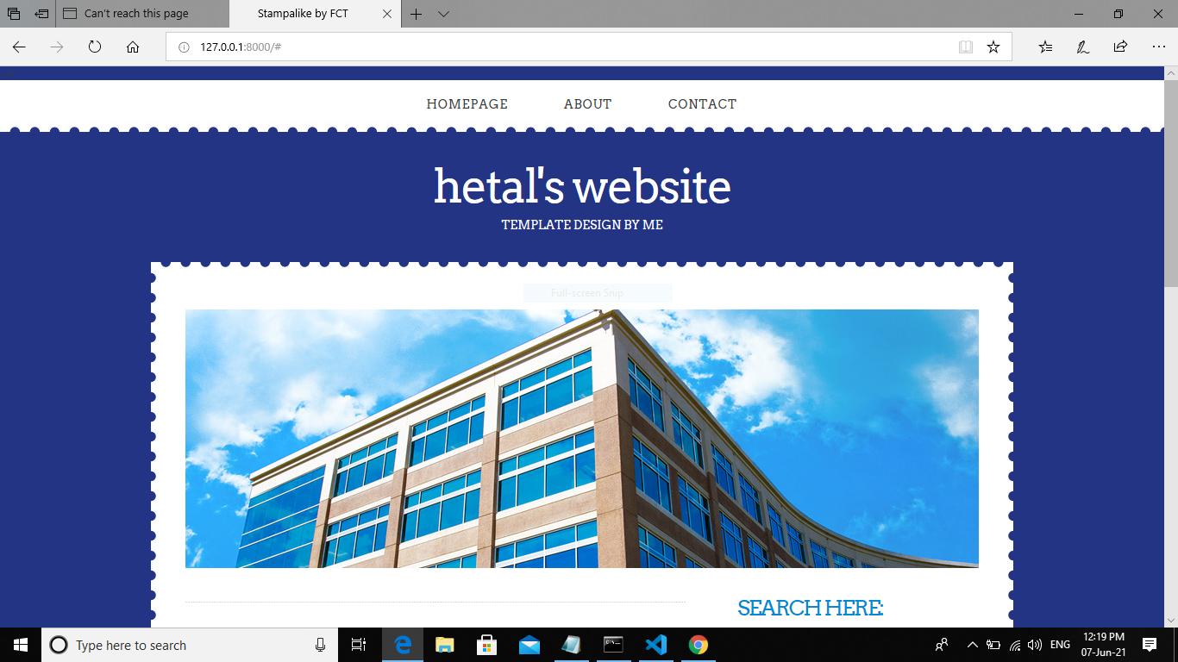
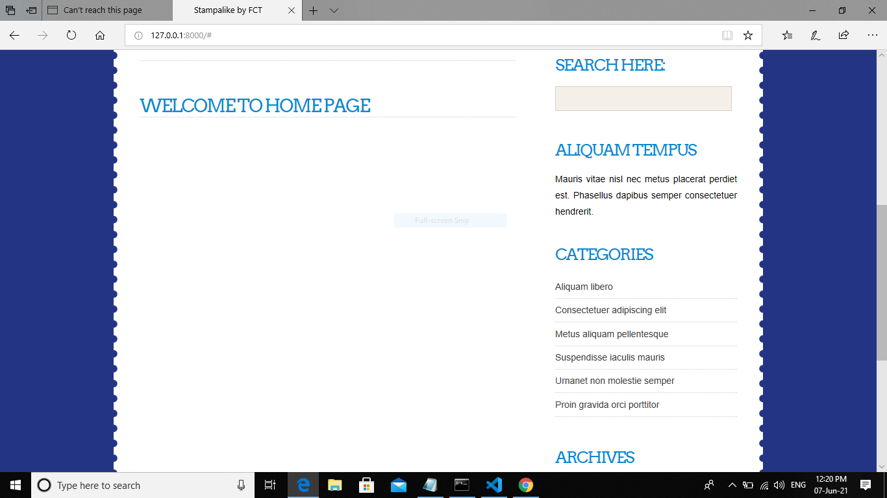

About page:-

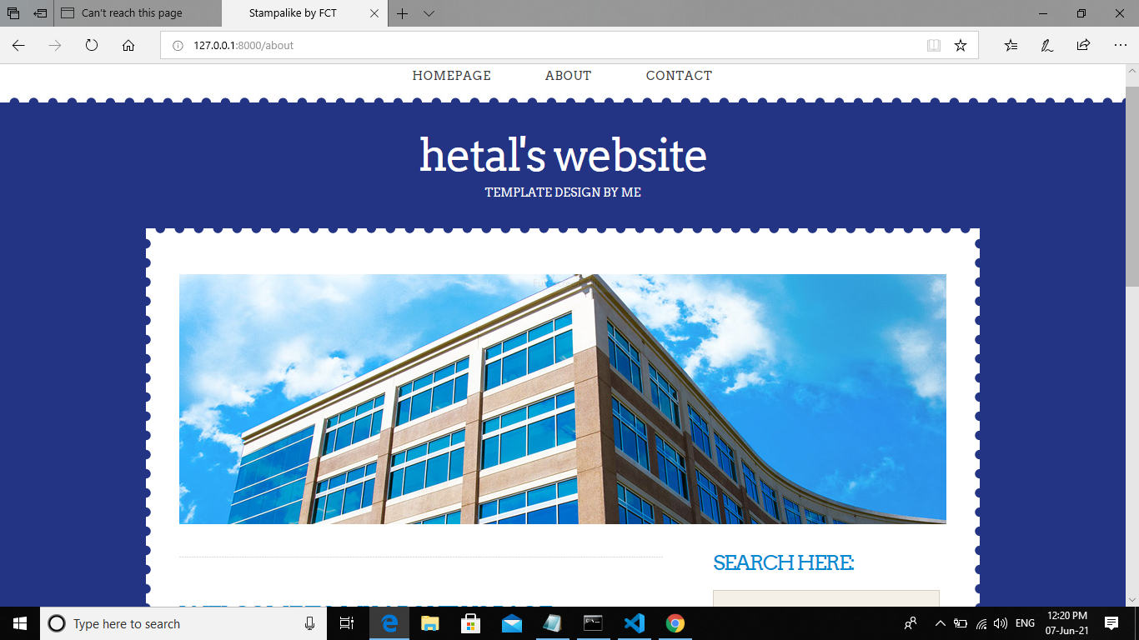
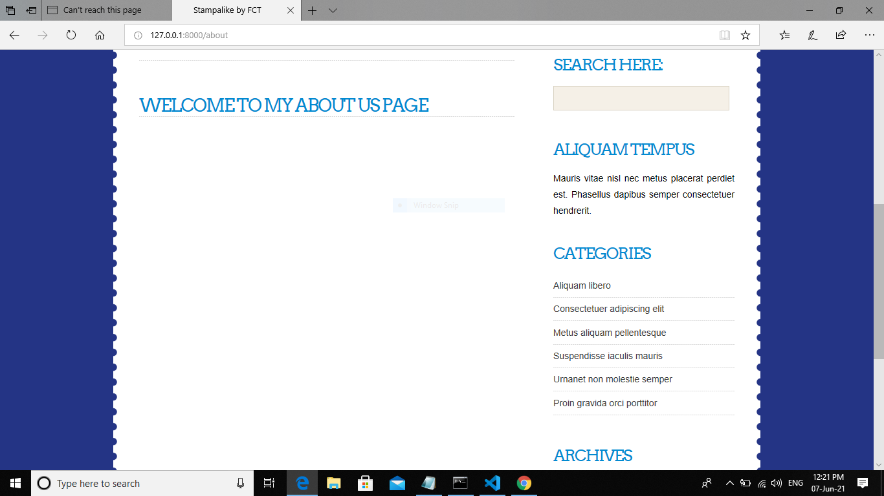

Contact page :-
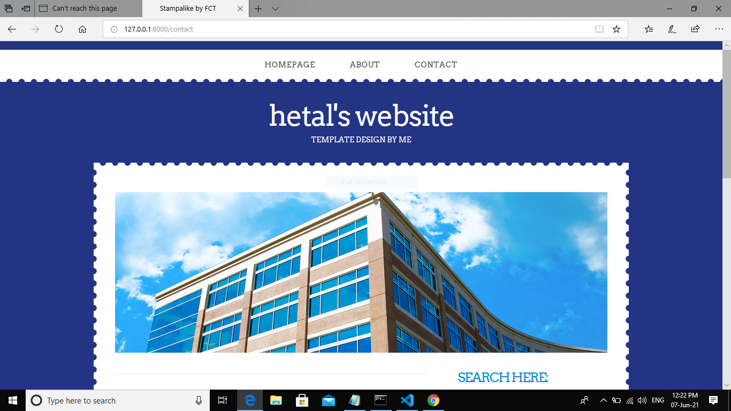

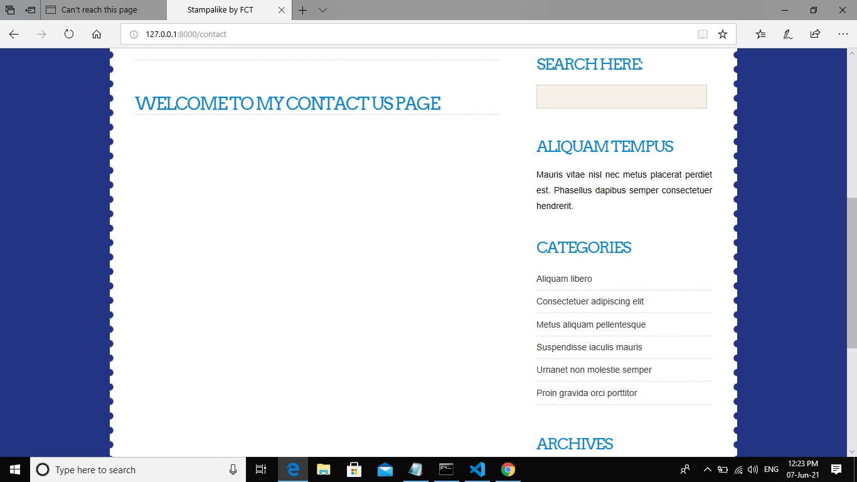

Data in stamp:-
{% extends 'base.html' %}

{% block content %}

<h1>Welcome to my contact us page</h1>
<form>
Name:<input type='text' name='txt1'/>
</form>
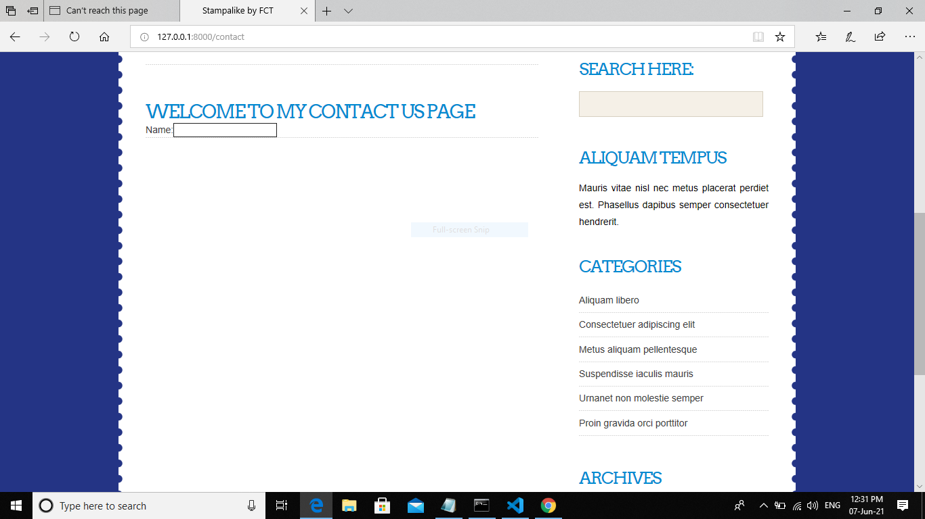
{% endblock %}

